1.1

Last year:

First quarter: +15k

Second Quarter: +425k

Third Quarter: + 30k

Fourth: +94k

Year: +564k.

Detail by month:

1. **-27k**
2. +28k
3. +13k
4. +75k
5. +157k
6. +194k
7. +74k
8. **-105k**
9. +60k
10. +96k
11. **-10k**
12. +8k

Jan: year start nervousness. Aftermath: control position on January.

Aug: Liquidation (due to margin trading, position adding and offloading too aggressive and fast.)

Aftermath: no more leverage was used after this.

Nov: year end profit taking. 11/23-11/27 thurs-fri-mon continuation. Aftermath: cut position.

Second half of the year didn’t generate much pnl.

2018 Trading improvements:

Stocks:

* Post crash T close accumulation
* Post crash T+1 PM accumulation

Futures:

* Surreptitious post close discount accumulation.
* PMCL autocorr

Stock strategy:

1. Pick high sharpe stocks
2. Start trading at 2:30, pick up low closers
3. Low closers tend to open lower, pick up more here.
4. Sell T-1 positions at close
5. Sell T-2 bot positions on open (tend to open high after high close)

1.2

Futs at 0.5 premium.

1.3

Trend pnl continue to rally on stock+fut portfolio.

Checked last year’s trading performance for futs.

Aug bad performance was due to liquidation.

Aug 3 was a liquidation. Too much position was bought intraday. You should wait until liquidation is finished and accumulate end of day, this is a source of high sharpe pnl. Your trading showed a lot of impatience and you liquidated on Aug 9th.

4% correction at the beginning of Aug threw you off the boat like that. Not good.

Errors (last Aug)

1. Too much intraday buying (no additional buying unless trading pnl is positive)
2. Hoping for intraday rebound. This rebound needs to repaid the next day so it is not a good pnl. You should look for zero rebound and total liquidation and big crash of PD.
3. When market crashes to the point where nobody wants to buy, that is the point of entrance. Aim at PD reversion in the short term. Target day traders who need to buy back their position.
4. Don’t waste energy look at the market in the AM, and PMs where previous PM was not a crash.
5. If previous day ended high, no point of trading.

1.5

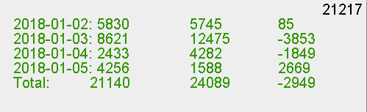

This week is the first trading week of the year 2018. Markets were strong. Moutai up 6%.

Trend pnl is strongly up. PM correction is healthy.

1.7

Testing stock strategy:

1. Guaranteed by long term sharpe
2. Pick up at day’s close
3. Intraday crashes